**Food website**

PROJECT REPORT

*Submitted by*

Jiya Bharti

***in partial fulfillment for the award of the degree***

***of***

**bachelor of technology**

**in**

**computer science and engineering**



Lovely Professional University, Punjab

November 15

**Lovely Professional University, Punjab**

**BONAFIDE CERTIFICATE**

Certified that this project report **“……….Food website……………..”**

is the bonafide work of “**…………..Jiya Bharti.…………...”**

who carried out the project work under my supervision

**SIGNATURE**Shivani Sharma

**SUPERVISOR**

**SIGNATURE**

Dr. Harminder Singh Saggu

**HEAD OF THE DEPARTMENT**

**TABLE OF CONTENTS**

|  |  |  |
| --- | --- | --- |
| CHAPTER NO. | CHAPTER NAME | PAGE NO. |
| 1. | Title Page | 1 |
| 2. | Bonafide Certificate | 2 |
| 3. | Abstract | 3 |
| 4. | Table of Contents | 4 |
| 6. | List of Figures | 21 |
| 7. | List of Symbols, Abbreviations and Nomenclature | 23 |
| 8. | Chapter 1 | 24 |
| 9. | Chapter 2 | 26 |
| 10. | Chapter 3 | 27 |
| 11. | Conclusion | 29 |
| 12. | References | 29 |

**ABSTRACT**

In a modern generation Online food ordering is a mobility of food delivery

or takeout from a local restaurant or food cooperative. Now days the rapid

growth in the use of internet and the technologies associated with it, the several

opportunities are coming up on the web or mobile application. This is made

possible through the use of electronic payment system. The payment can be

done through the customer’s credit card, debit card. It is possible for everyone

to order any goods from anywhere the internet and have the goods delivered at

his/her home. All types made be internet le transaction ads to the economic of

digital cash, the necessary tool for this process telecommunication with

customers. The system will become an important tools use for restaurant to

improve the management aspect by use of computer system to connected each

and every food ordering transaction instead of data record on it. In addition, it

can also provide efficiency for the restaurant by reducing time consuming,

minimize human errors or delivery and providing good quality and service to

customers. In terms of the integrity and availability of the system provided, it

can be concluded that this system is a suitable solution.

**List of figure**

**Code:**

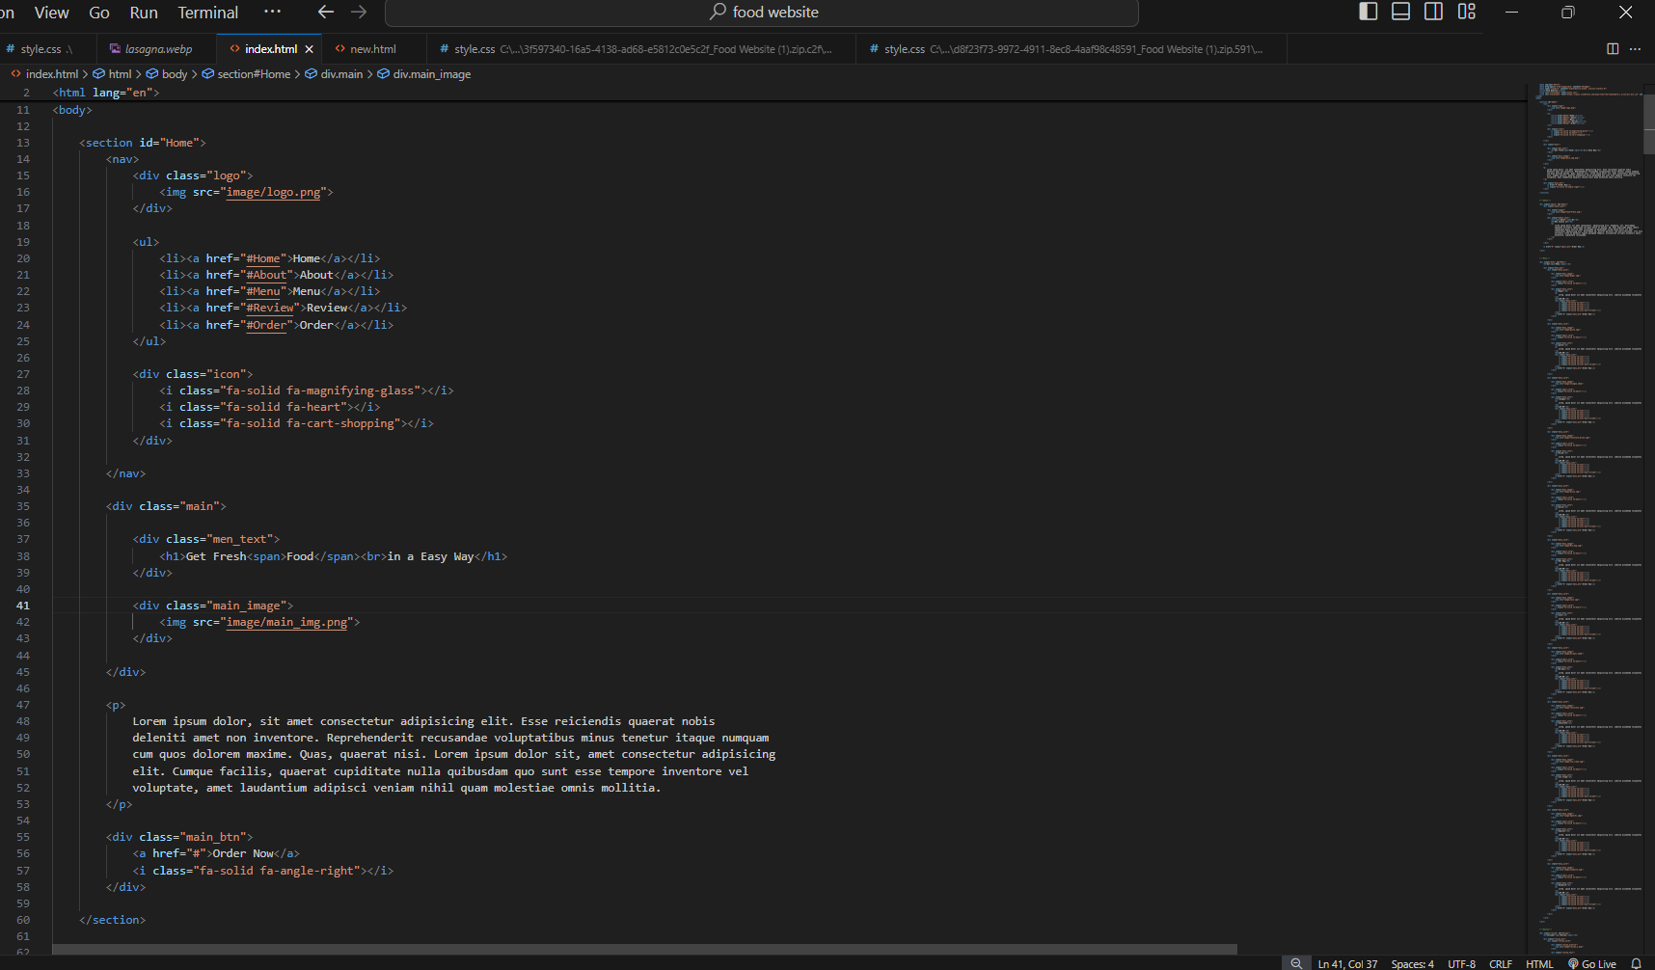

Output: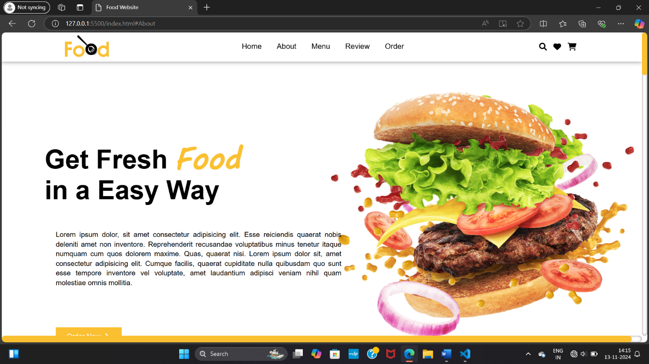

Code:

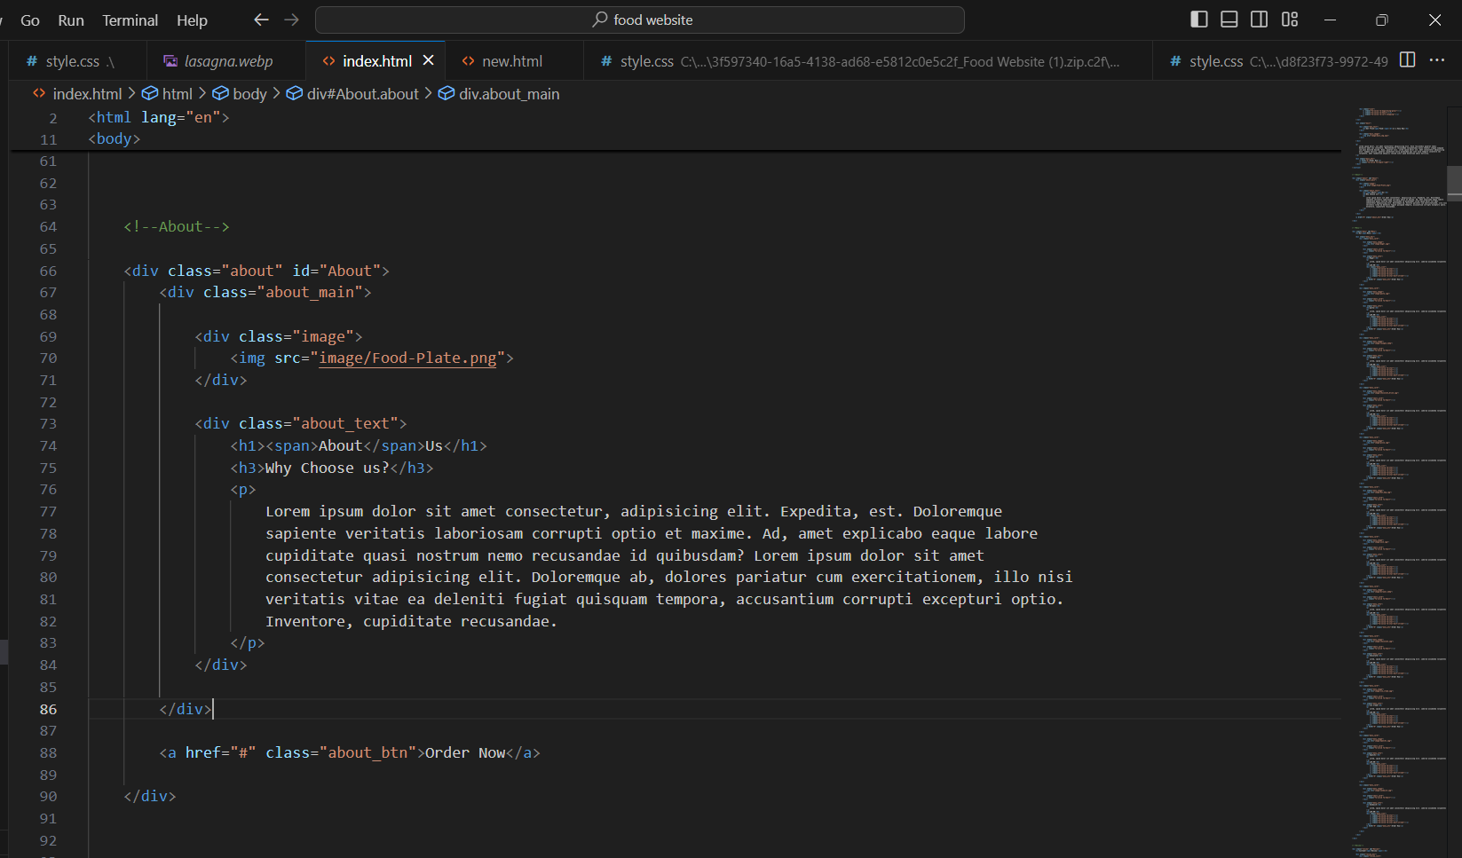OUTPUT:

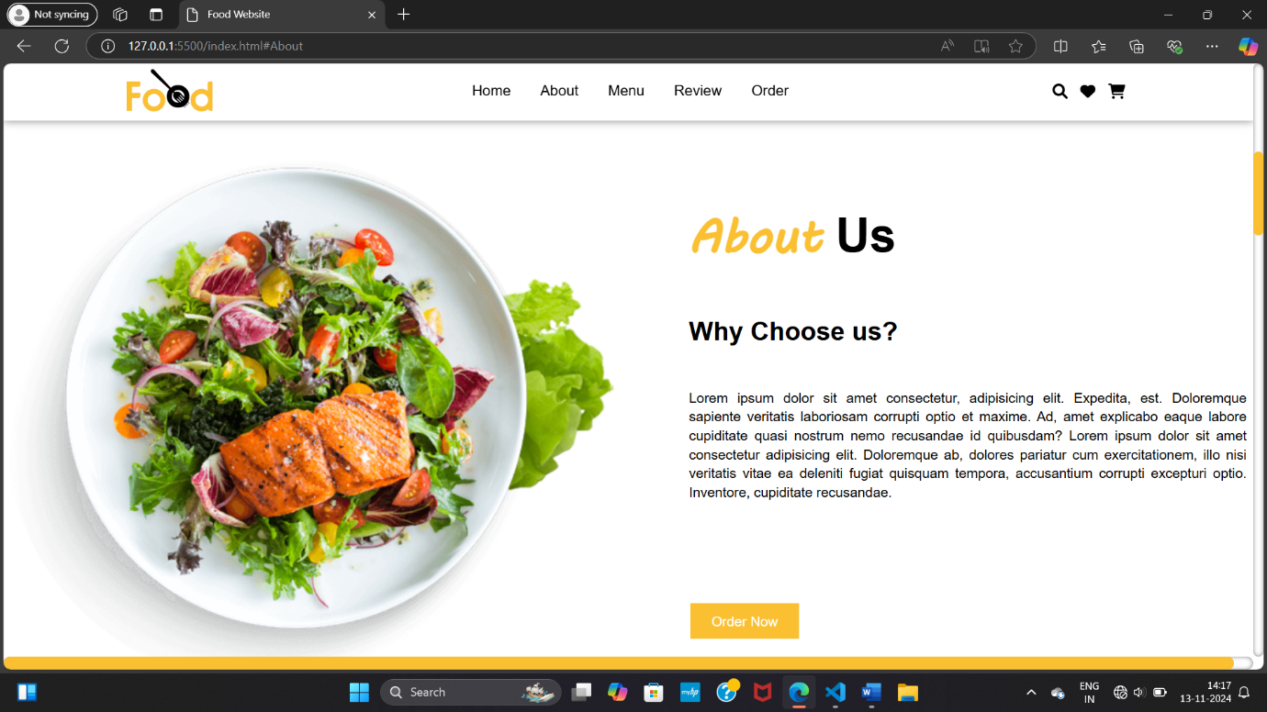

CODE:

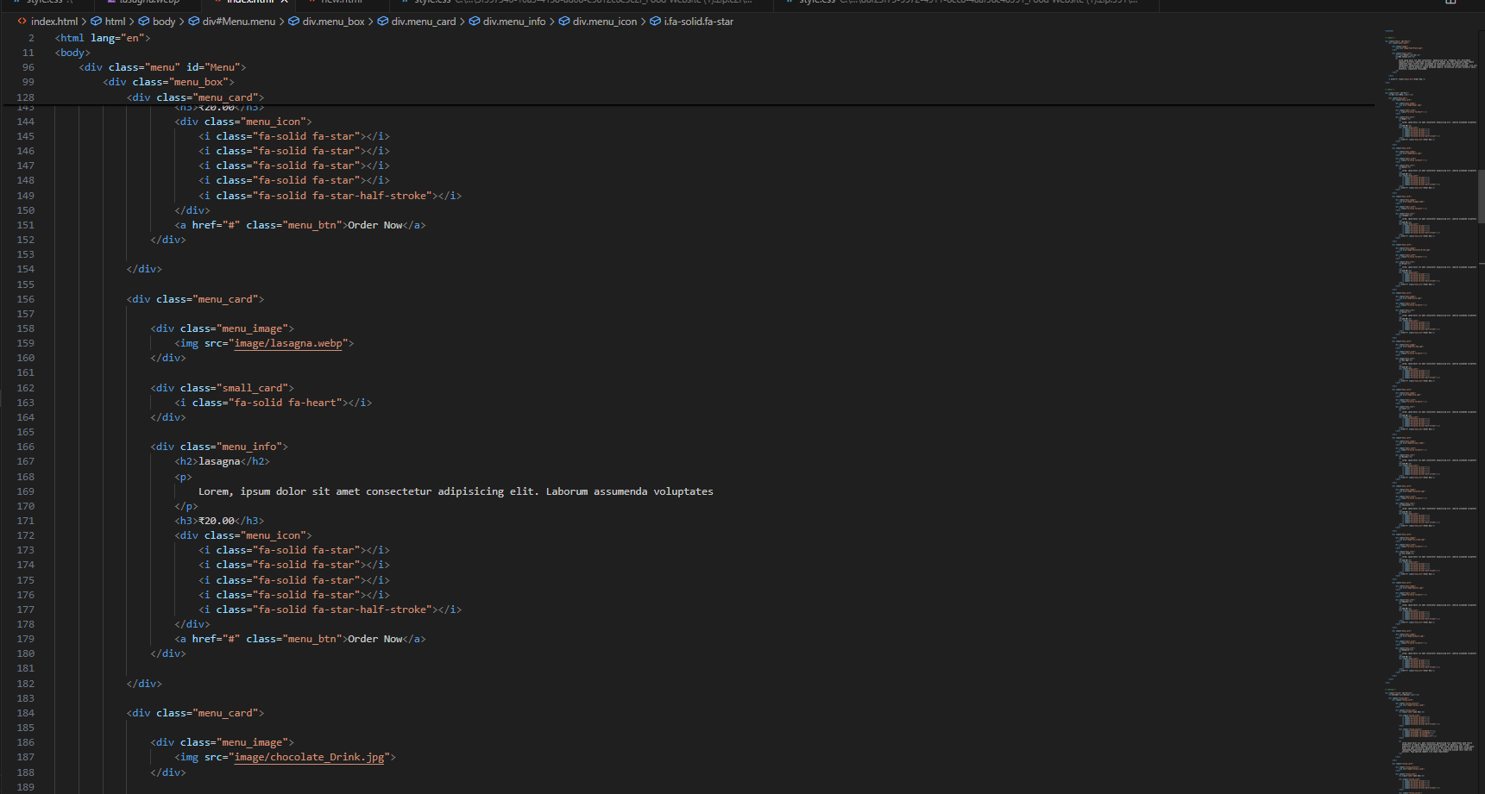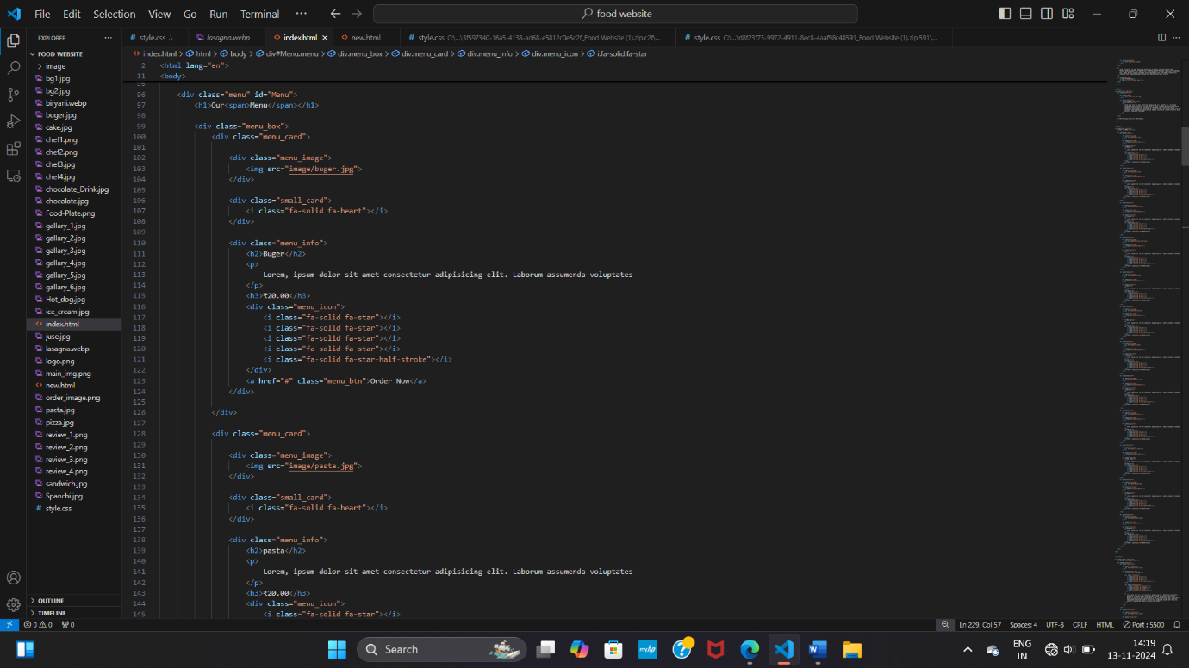

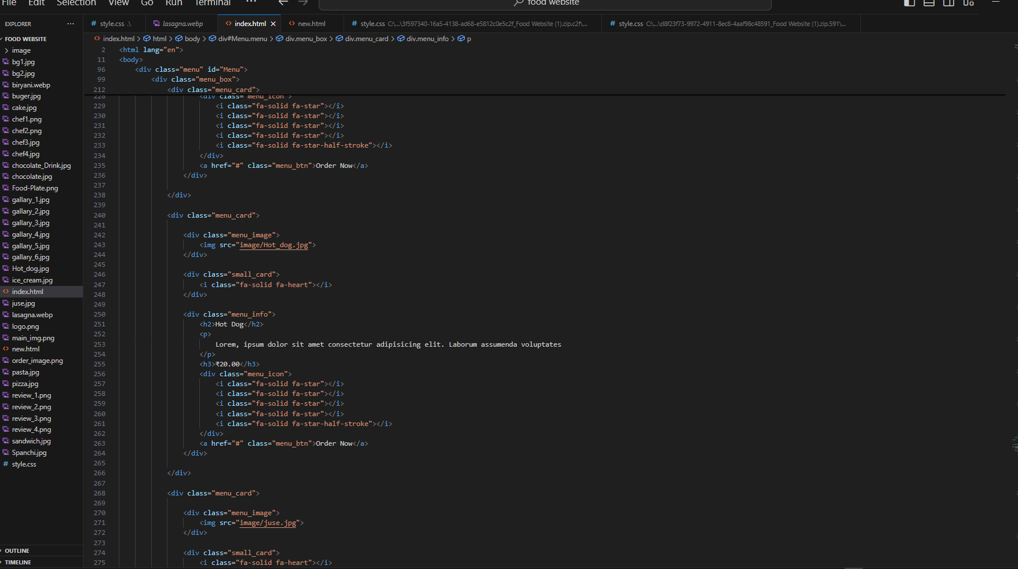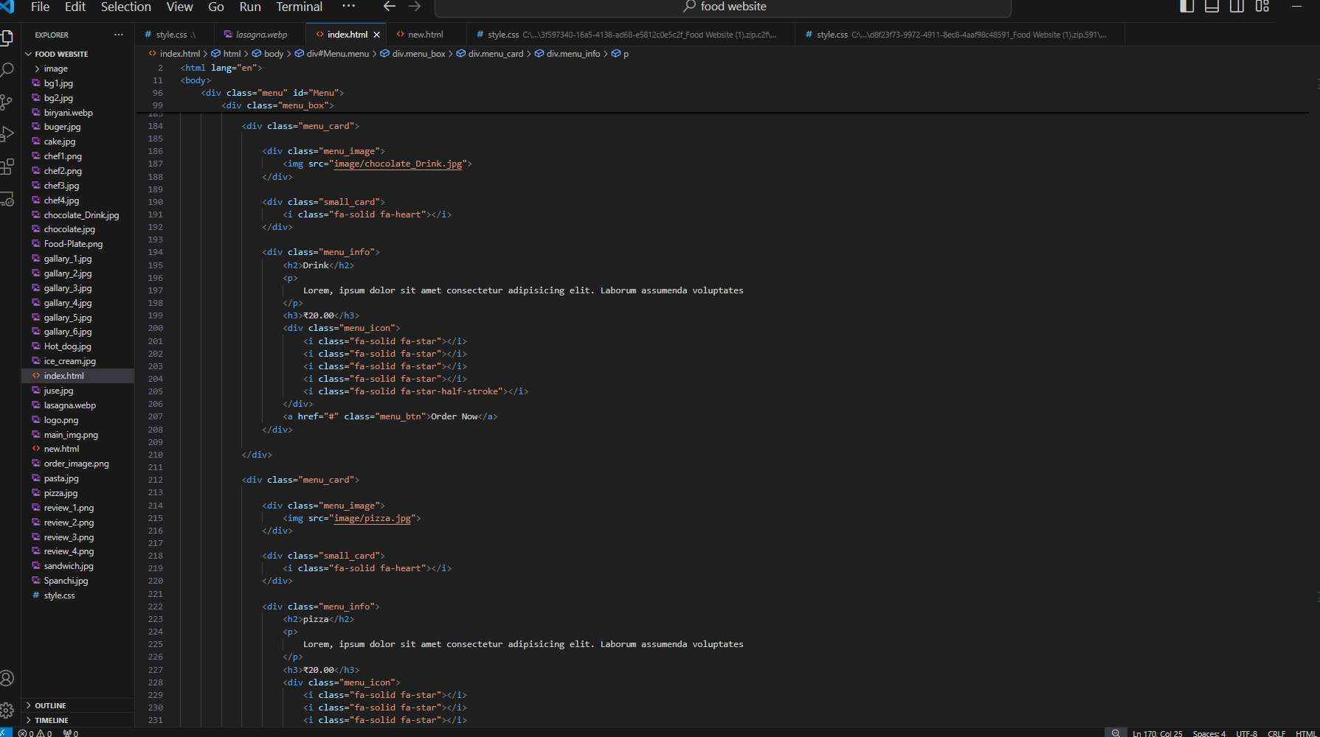

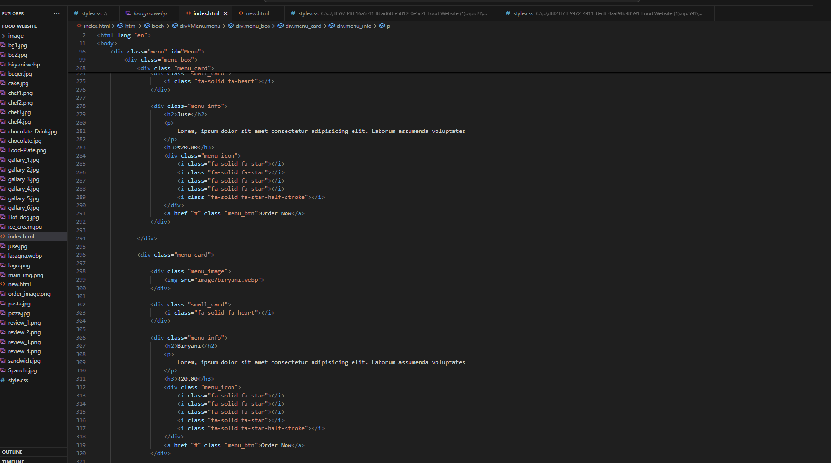



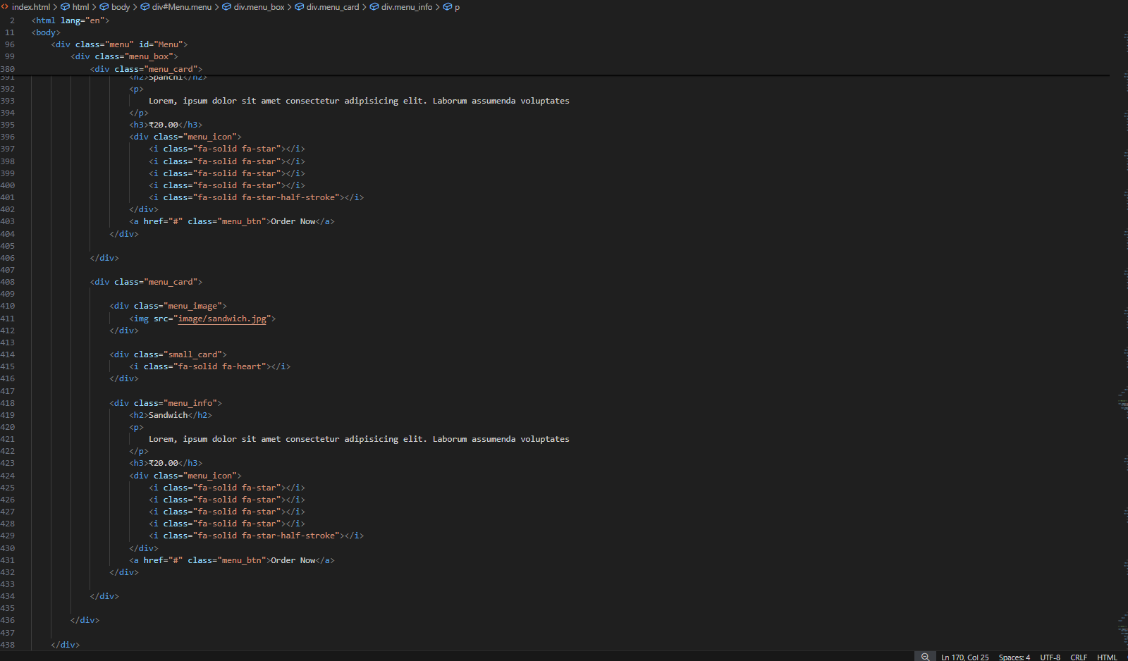

OUTPUT:

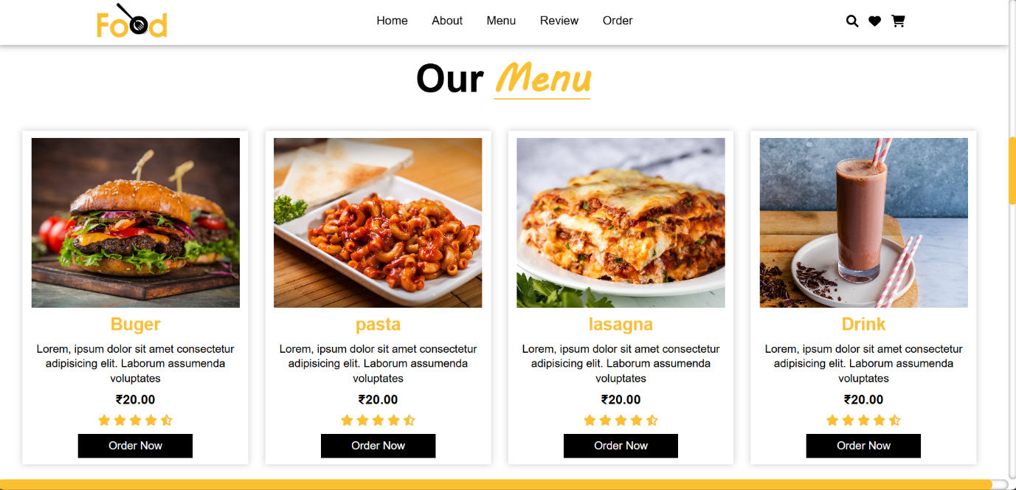

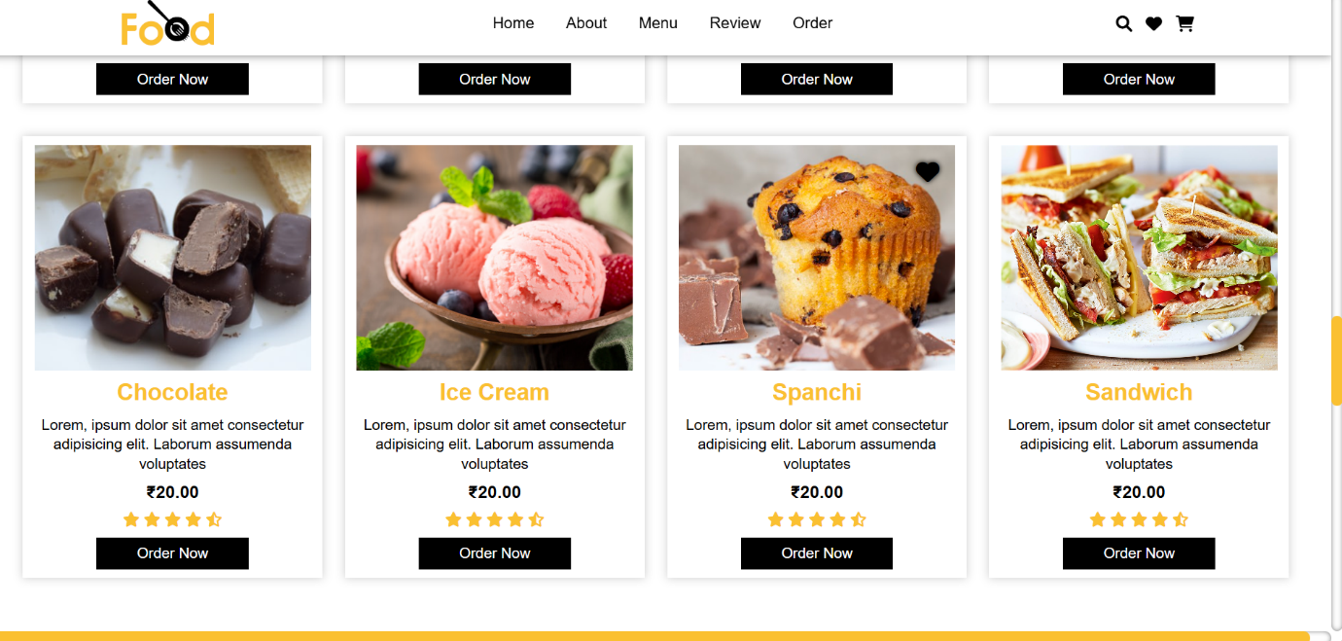

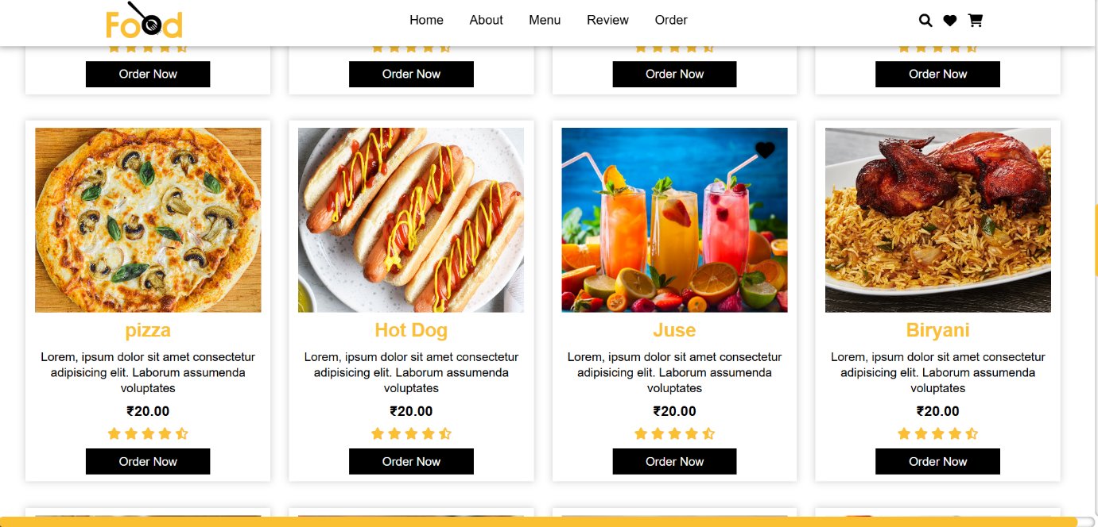

CODE:

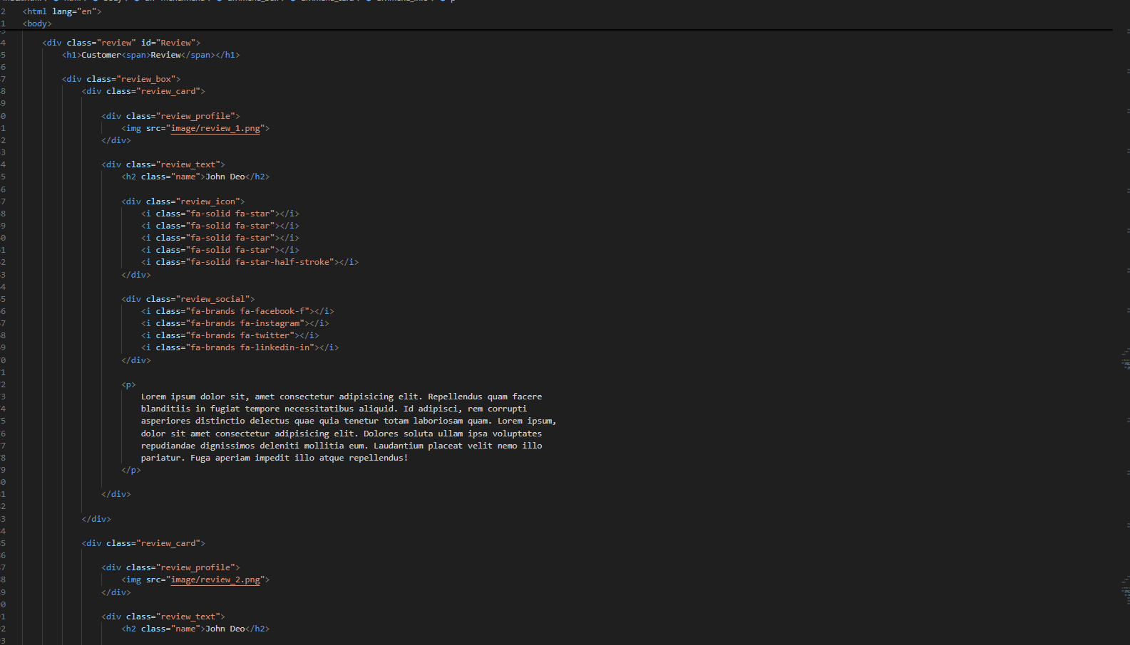

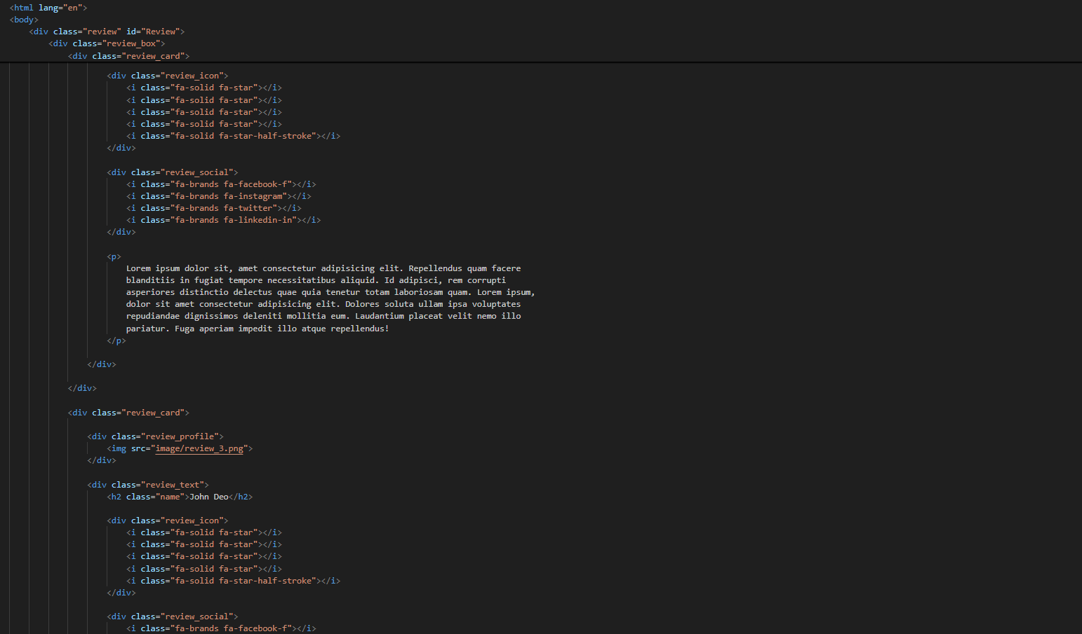

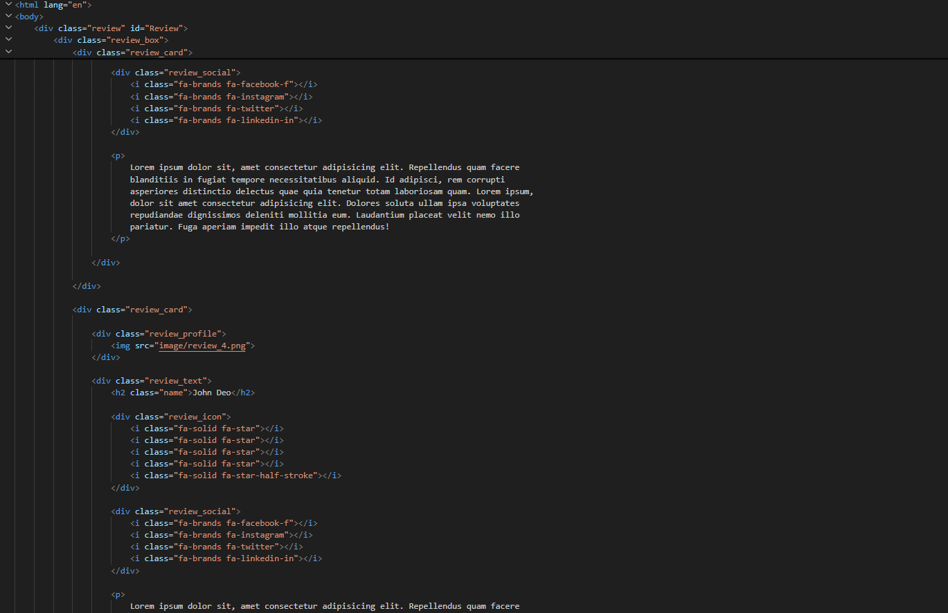h

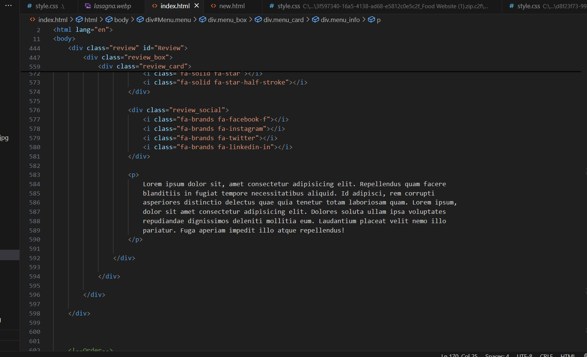

output:

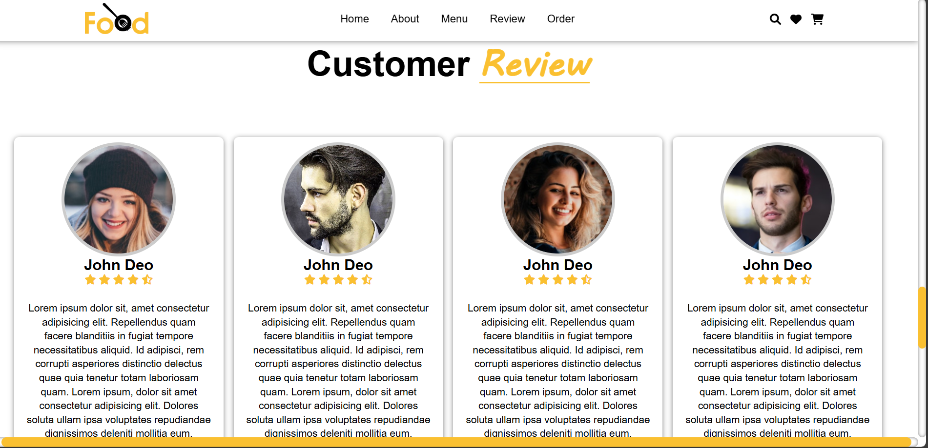

code:



Output:

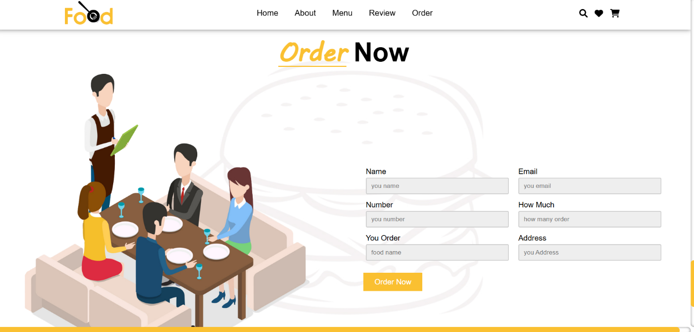

code:

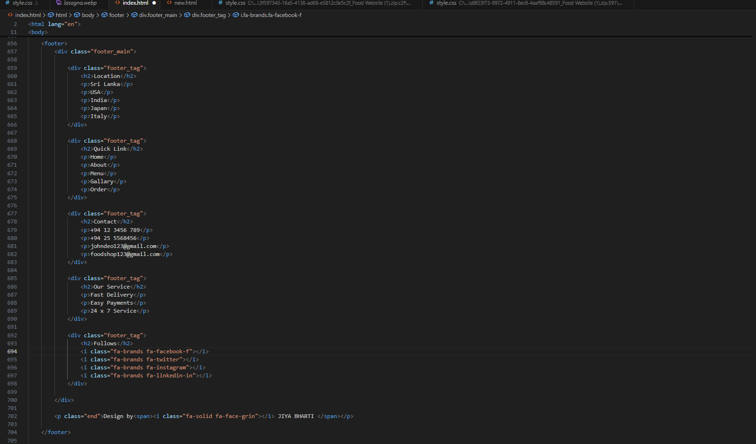output:

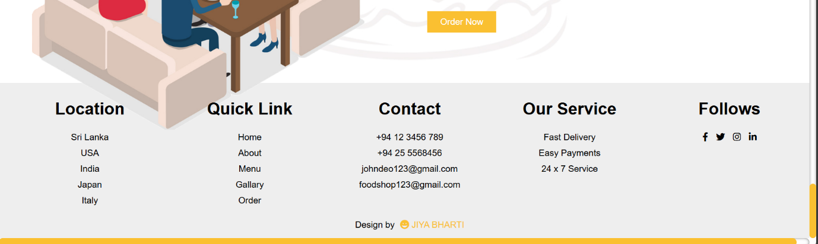

***CSS Code:***





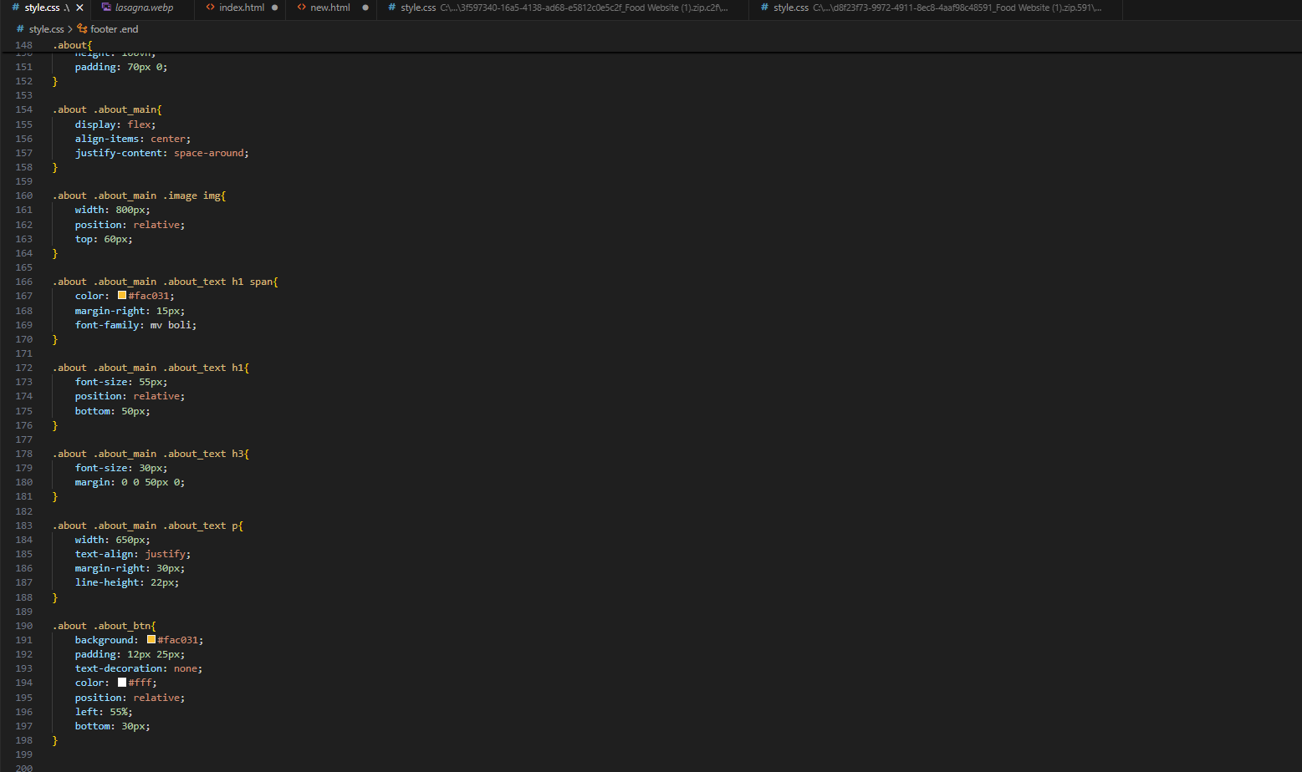













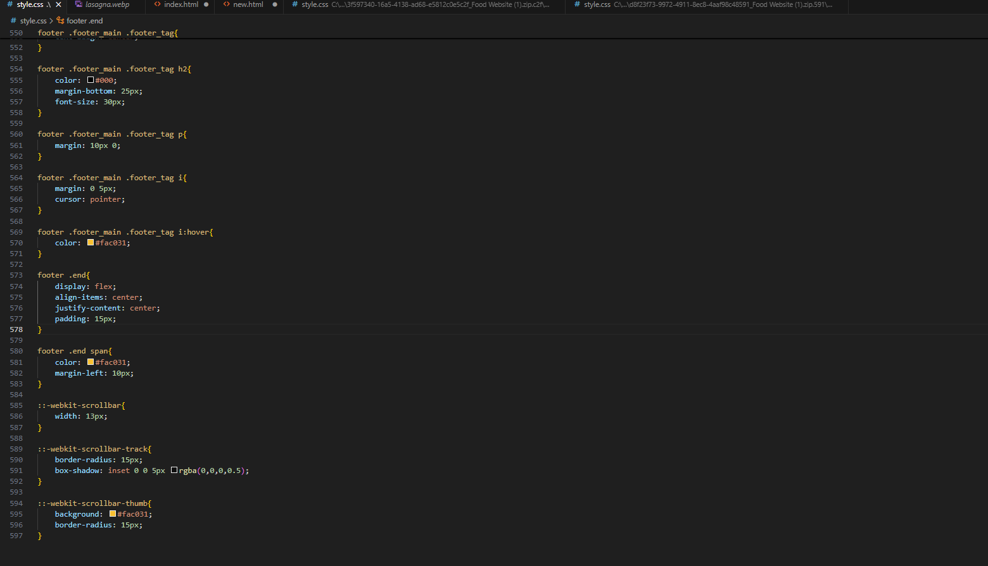

**LIST OF SYMBOLS:**

|  |  |
| --- | --- |
| SYMBOLS | DESCRIPTION |
| & | Used to display the ampersand symbol without causing HTML parsing issues. Often used in URLs. |
| ° | Displays the degree symbol; commonly used for temperature or angles. |
| ≠ | Displays not equal to; used in mathematics. |
| ≥ | Displays greater than or equal to; used in mathematical contexts. |
| < | Displays the less-than symbol. Necessary in HTML text content to avoid misinterpretation as an HTML tag. |
| > | Displays the greater-than symbol. Used similarly to avoid tag misinterpretation. |
| " | Used for double quotation marks in attribute values to prevent syntax errors. |
| × | Displays the multiplication symbol. Commonly used in mathematical expressions. |
| ≤ | Represents less than or equal to. Common in mathematical and scientific contexts. |

Chapter1: Food website

**Understanding the food website**

**1. Purpose of the Food Website**

The first step is to define the purpose of your website. Some possible focuses might include:

* Recipe Sharing: A website where users can find, share, and interact with recipes.
* Food Blog: Sharing food-related articles, reviews, trends, and lifestyle content.
* Restaurant Website: A platform for a restaurant or food service business, providing menus, reservations, and contact information.
* E-commerce for Food Products: Selling ingredients, packaged foods, or kitchen accessories.

**2. Target Audience**

Understanding who you’re designing for is key. Your audience could include:

* Home cooks or professional chefs looking for new recipes or inspiration.
* Health-conscious individuals seeking nutritious food options.
* Foodies looking for restaurant recommendations, reviews, or new trends.

**Our mission:**

our mission is to inspire, empower, and nourish people through the joy of food. We believe that cooking and enjoying food is not just about sustenance but about connection — to the people around us, to our culture, and to our own creativity in the kitchen. Whether you’re looking for delicious, easy-to-make recipes, healthy meal ideas, or simply the best food trends and tips, we’re here to bring you closer to the food you love.

We are dedicated to providing high-quality, accessible content that helps our community cook better, eat healthier, and experience the magic of food in every bite. From vibrant dishes to expert advice, we’re here to make your culinary journey as enjoyable and rewarding as possible.

**Overview:**

your ultimate destination for all things food. Whether you’re a seasoned chef, a beginner in the kitchen, or just someone who loves to eat, we’ve created a space where food lovers of all kinds can find inspiration, share experiences, and discover new ways to enjoy their meals.

**key objective**

On our website, you’ll find a wide range of content, including:

* **Delicious Recipes**: From quick weeknight dinners to elaborate holiday feasts, our extensive recipe collection is designed to suit every taste and skill level. Explore recipes with clear instructions, nutritional info, and beautiful images to guide you every step of the way.
* **Healthy Eating Tips**: We believe that food should nourish both body and soul. Our health-conscious recipes and nutrition advice help you make smarter choices without sacrificing flavor.
* **Cooking Tips & Hacks**: Whether you're looking to improve your cooking techniques or need a quick kitchen hack, we’ve got you covered with expert advice and time-saving tips.
* **Food Trends & Inspiration**: Stay up-to-date with the latest food trends, ingredients, and culinary innovations from around the world.
* **Community Engagement**: Join a vibrant community of food enthusiasts by sharing your favorite recipes, tips, and meal ideas. We believe that food brings people together, and we love to foster connections through cooking.

**Chapter 2: Technological Used**

**1. Web Development Technologies**

* **HTML (Hyper Text Markup Language)**: The fundamental building block of any website, HTML is used to create the structure and content of the web pages. It defines elements such as headings, paragraphs, links, images, and tables.

* **CSS (Cascading Style Sheets)**: CSS is used to style the website, controlling layout, colours, fonts, and overall appearance. It allows for responsive design, ensuring that the website looks good on various devices (desktops, tablets, and smartphones).

Chapter 2 concludes by summarizing the critical technological advances that fuelled the Green Revolution and their transformative effects on agriculture. It emphasizes that while these innovations led to significant increases in food production and agricultural efficiency, they also laid the groundwork for future challenges, including environmental sustainability and reliance on chemical inputs.

**2. Sustainability and Eco-Conscious**

* **Sustainable Recipes**: We offer a collection of plant-based, seasonal, and locally sourced recipes that prioritize environmentally friendly ingredients. These recipes are designed to minimize food waste, reduce the carbon footprint of your meals, and showcase the incredible flavors that come from nature’s bounty.

**3. Eco-Friendly Packaging**

* food packaging is a major contributor to environmental waste, especially plastic. Many food items are unnecessarily wrapped in layers of plastic, contributing to pollution in landfills and oceans. Whenever possible, choose packaging-free or recyclable options. Consider buying in bulk, using reusable bags, and supporting companies that use sustainable or compostable packaging.

**4. diversity**

* we believe that food is a bridge that connects us to the world’s diverse cultures. Exploring these global flavors allows us to experience the beauty of different traditions, rituals, and ways of life. Here’s why we should embrace cultural food

- Latin American Flavors: Rich, Hearty, and Festive

-Asian Street Food: Bold, Flavorful, and Fun

-Indian Cuisine: Spices, Flavors, and Traditions

-Mediterranean Flavors: Fresh, Light, and Vibrant

Chapter3: **Research and Development**:

**Identifying Current Food Trends**

Keep a pulse on current food trends—these can include new ingredients, dietary preferences, cooking techniques, or innovative takes on classic dishes. You can gather insights from:

* **Social Media & Food Communities**: Platforms like Instagram, Pinterest, and TikTok are great for spotting emerging food trends. Follow top chefs, influencers, and food bloggers for inspiration.
* **Food Industry Reports**: Companies like **Mintel** and **NPD Group** release consumer food trend reports that provide insights into shifts in eating habits, new products, and popular ingredients.
* **Culinary Magazines and Blogs**: Stay up-to-date with publications like **Bon Appétit**, **Eater**, and **Food & Wine** to see what's hot in the culinary world.

**Testing and Refining Recipes**

Once you've identified a trend or ingredient to explore, test the recipe thoroughly to ensure it’s both delicious and easy to make. This might involve:

* **Trial and Error**: Make adjustments to the recipe, testing ingredient quantities, cooking times, and presentation.
* **User Feedback**: If your website allows user engagement (comments, social media shares, etc.), encourage feedback on your recipes to understand what works and what can be improved.
* **Expert Advice**: Collaborate with professional chefs or food specialists to fine-tune recipes and ensure they meet high culinary standards.

**Nutritional Information and Dietary Preferences**

As dietary preferences (e.g., vegan, gluten-free, keto, paleo) become more diverse, it’s important to develop recipes that cater to these needs:

* Ensure your recipes include nutritional information, such as calorie counts, protein, fats, and carbs.
* Test variations of popular recipes that are compatible with different diets (e.g., a gluten-free version of pizza dough or vegan baking substitutes).
* Consider health-conscious alternatives like reducing sugar or incorporating more whole grains and vegetables.

**Recipe Style and Presentation**

Your website's recipe format should be clear, easy to navigate, and visually appealing:

* Include **step-by-step instructions** with photos or videos, making it easy for both beginners and experienced cooks.
* Make sure to incorporate a **printable recipe card** for convenience.
* Include tips, variations, and ingredient substitutions to add flexibility for different types of home cooks.

CONCLUSION:

Creating a successful food website is more than just sharing recipes—it's about cultivating a space where people can connect with food on a deeper level. From celebrating cultural cuisines and sustainability to developing innovative recipes and exploring new culinary trends, your website has the potential to inspire, educate, and nourish your audience.

By focusing on key areas like recipe development, ingredient exploration, cooking techniques, food photography, and understanding your audience's needs, your food website can become a go-to resource for those seeking both inspiration and practical guidance in the kitchen. Continuous research and development will ensure that your site remains fresh, dynamic, and aligned with the latest food trends, while also honoring the rich history and cultural diversity that food represents.

Ultimately, the goal is to foster a love for food that extends beyond the kitchen. Whether it’s encouraging sustainability, exploring new flavors, or learning about the stories behind each dish, your website can become a celebration of food’s ability to bring people together, spark creativity, and create memorable experiences. So, embrace your passion for food, keep exploring new ideas, and share the joy of cooking and eating with the world.

**References:**

* W3school : For foundation of HTML and CSS
* Chatgpt : For guidance, suggestion and code refinment throughout the project